

Use Case Specification: eCL Employee Review
For
eCoaching Log

Change History Log

Date | Version | Description | Author
01/12/2015 | 1.0 | Initial Document | Doug Stearns

Table of Contents

1. Brief Description 5
2. Participating Actors 5
2.1 Primary 5
2.2 Secondary 5
3. Basic Flow of Events 6
3.1 Access eCoaching Log website My Dashboard page. 6
3.2 Select eCoaching Log from My Pending eCoaching Logs section with status of Pending Employee Review. 6
3.3 Read and review information on the review page. 6
3.4 Check the box to acknowledge the coaching opportunity (required entry). 6
3.5 Enter any comments or feedback (free form text up to 3000 characters). 6
3.6 Submit to complete eCoaching Log. 6
4. Alternative Flows 7
4.1 Select Pending Acknowledgement coaching log (CSR Employee only). [Step 3.2] 7
4.2 Select Completed coaching log. [Step 3.2] 7
5. Preconditions 7
5.1 eCoaching Log website available. 7
5.2 eCoaching Log database available. 7
5.3 eCoaching Log database populated with correct and current hierarchy information for Employee, Supervisor, Manager. 7
5.4 eCoaching Log Submissions and Notifications have taken place. 7
5.5 eCoaching Log Dashboard is available. 7
6. Postconditions 7
6.1 Appropriate review information is written to database. 7
7. Assumptions and Dependencies 7
7.1 Access to Employee Review will be limited to those who are the recipient of coaching logs. 7
8. Business Rules 8
8.1 none 8
9. Technical Requirements 8
9.1 none 8
10. Activity Diagrams 9

Table of Figures
Figure 1 – eCL Employee Review 8

Brief Description
eCoaching Log Review for Employees who are the recipient of coaching logs. It allows the employee to review coaching notes and comments and acknowledge receipt of log and coaching. Note: the recipient of coaching logs can be CSR Employees, Supervisor Employees, Quality Specialists, or LSAs.

Participating Actors

Primary

Employees (recipient of eCoaching Log)

Secondary

None

Basic Flow of Events

Access eCoaching Log website My Dashboard page.

Select eCoaching Log from My Pending eCoaching Logs section with status of Pending Employee Review.

Read and review information on the review page.

Check the box to acknowledge the coaching opportunity (required entry).

Enter any comments or feedback (free form text up to 3000 characters).

Submit to complete eCoaching Log.

Alternative Flows

Select Pending Acknowledgement coaching log (CSR Employee only). [Step 3.2]

Select eCoaching Log from My Pending eCoaching Logs section with a Pending Acknowledgement status.

Read and review information on the review page.

Check the box to acknowledge the coaching opportunity (required entry).

Continue with Step 3.6 above.

Select Completed coaching log. [Step 3.2]

Select eCoaching Log from My Completed eCoaching Logs section with a Complete status.

Read and review information on the review page.

Close review page.

Preconditions

eCoaching Log website available.

eCoaching Log database available.

eCoaching Log database populated with correct and current hierarchy information for Employee, Supervisor, Manager.

eCoaching Log Submissions and Notifications have taken place.

eCoaching Log Dashboard is available.

Postconditions

Appropriate review information is written to database.

Assumptions and Dependencies

Access to Employee Review will be limited to those who are the recipient of coaching logs.
Module | Employee | Job Codes
CSR | CSR | WACS01, WACS02, WACS03
Supervisor | Supervisor | WACS40
Quality | Quality Specialist | WACQ02, WACQ12
LSA | LSA | WIHD01, WIHD02, WIHD03, WIHD04

Business Rules

none

Technical Requirements

none

Activity Diagrams
Below is the activity diagram for the use case that provides a visual depiction of the flow of events.

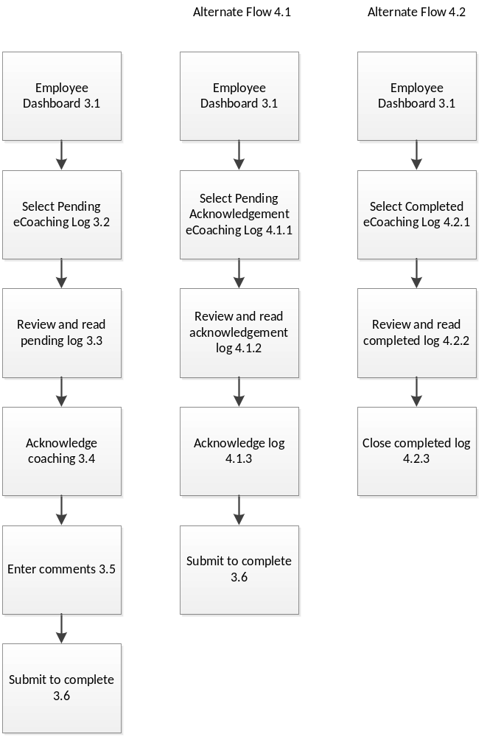
Figure 1 – eCL Employee Review

